MODERN SLAVERY POLICY
Joule Hot Water Systems UK Ltd
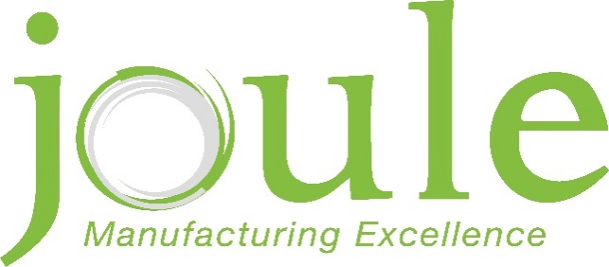

Contents
Contents 2
Introduction 3
Regulation 3
Comittments 3
General 4
Version Control 4

Introduction

The purpose of this policy is to ensure all employees understand the commitment Joule Hot Water Systems UK Ltd have, to driving out acts of modern slavery and human trafficking within its business and that from within its supply chains, including suppliers, sub-contractors, and partners.

REGULATION

The organisation acknowledges the responsibility to the Modern Slavery Act 2015 and will ensure transparency within the organisation and with suppliers of goods to the organisation. These as well as the suppliers of services make up the main supply chain within Joule UK.
As part of the company’s due diligence processes into modern slavery and human trafficking the supplier approval process incorporates a review of the controls undertaken by the supplier. Imported goods from sources outside the UK & EU are potentially more at risk from modern slavery/ human trafficking issues. The level of management control required for these sources will be continually monitored.
The company will not support or deal with any business knowingly involved in modern slavery or human trafficking.

The company directors and senior management shall take responsibility for implementing this policy statement and its commitments and shall provide adequate resources (including information, instruction, monitoring and reporting issues etc.) and investment to ensure that modern slavery and human trafficking is not taking place within its supply chains.

COMMITMENTS

We shall be a company that expects everyone collaborating with us or on our behalf to support and uphold the following measures to safeguard against modern slavery and human trafficking:
- We have a zero-tolerance approach to modern slavery in our organisation and our supply chains;
- The prevention, detection and reporting of modern slavery and human trafficking in any part of our organisation or supply chain is the responsibility of all those working for us or on our behalf. Workers must not engage in, facilitate, or fail to report any activity that might lead to, or suggest, a breach of this policy;
- We are committed to engaging with our stakeholders and suppliers to address the risk of modern slavery and human trafficking in our operations and supply chain; and
- If we find that other individuals or organisations working on our behalf have breached this policy, we will ensure that we take appropriate action.

General

A full copy of this policy and a copy of the Modern Slavery Act 2015 will be accessible to all employees electronically and can be obtained from the HR department. The Company aims to keep policies up to date and right for everyone. Therefore, this policy may be amended from time to time, and it does not form part of your contract of employment.

Version Control

Joule UID | JUK-HR-PLCY-023-001
Department | Human Resources
Owner (job title) | HR Manager
Created | 20 Aug 2024
Review date | 20 Aug 2026

Version | Date | Author | Status | Comment / changes
1.0 | September 2024 | Caroline Galdas, HR Manager | New | New Policy

